**PROGRAM 3: Finding partial derivatives, Jacobian and plotting the graph**

**a)** Find the first order partial derivative of f = sin2x + cos2y w.r.t. x and y.

syms x y

f=sin(x)^2+cos(y)^2;

p1=diff(f,x)

p2=diff(f,y)

subplot(2,2,1)

fplot(p1,[-1,1])

title ('partial derivative wrt x')

subplot(2,2,2)

fplot(p2,[-1,1])

title ('partial derivative wrt y')

b) Find the second order partial derivative of f = sin2x + cos2y w.r.t. y.

syms x y

f=sin(x)^2+cos(y)^2;

p3=diff(f,x,2)

fplot(p3,[-1,1])

title ('plot of second order partial derivative of f wrt x')

c) Find the Jacobian of u = x(1-y), v = xy.

syms x y

u = x*(1-y);

v = x*y;

J=det(jacobian([u,v],[x,y]))

**PROGRAM 4: Applications to Maxima and Minima of two variables**

1. **Find the Maxima and Minima of f(x,y)= x^4+y^4 + x*y-1**

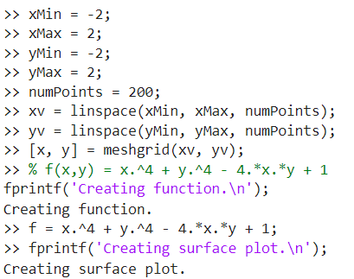

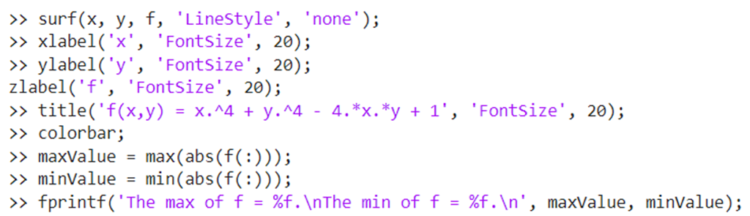

**b) Find the Maxima and Minima of f(x,y)= x^2+y^2-1**

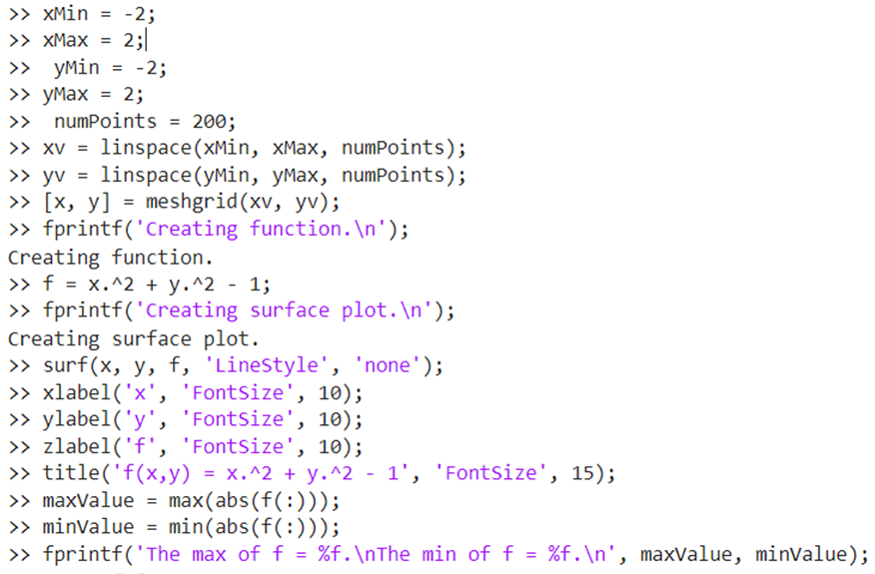

**Example 3: Find the Maxima and Minima of f(x,y)= x^4 + y^4 - x^2 - y^2 + 1**

>> xMin = -2;

>> xMax = 2;

>> yMin = -2;

>> yMax = 2;

>> numPoints = 200;

>> xv = linspace(xMin, xMax, numPoints);

>> yv = linspace(yMin, yMax, numPoints);

>> [x, y] = meshgrid(xv, yv);

>> % f(x,y) = x^4 + y^4 - x^2 - y^2 + 1

>> fprintf('Creating function.\n');

>> f = x.^4 + y.^4 - x.^2 - y.^2 + 1;

>> fprintf('Creating surface plot.\n');

>> surf(x, y, f, 'LineStyle', 'none');

>> xlabel('x', 'FontSize', 20);

>> ylabel('y', 'FontSize', 20);

>> zlabel('f', 'FontSize', 20);

>> title('f(x,y) = x^4 + y^4 - x^2 - y^2 + 1', 'FontSize', 20);

>> colorbar;